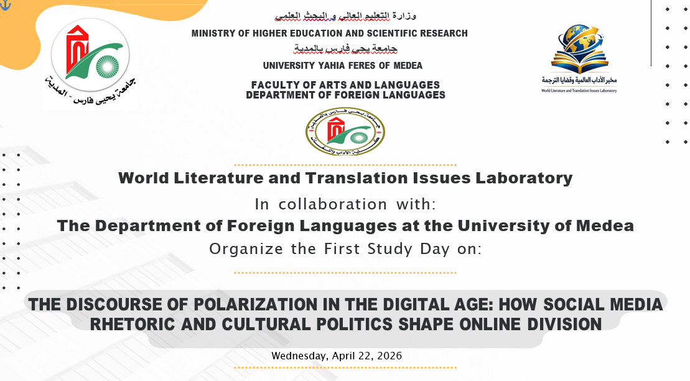

استمارة مشاركة

الاسم واللقب : ............................................
الدرجة العلمية : .................................................................. الجامعة : ..............................................................................
معلومات التواصل : البريد الالكتروني .............................................................................................
ٍرقم الهاتف : ...............................
نوع المشاركة : حضوريا عن بعد
محورالمشاركة: ...............................................................................................................................................................
عنوان المداخلة: ...........................................................................................................................................................
لغة المداخلة : العربية الإنجليزية الفرنسية
الملخص بالعربية :
............................................................................................................................................................................................................................................................................................................................................................................................................................................................................................................................................................................................................................................................................................…………………………………………………………………………………………………………………………………………………………………………………………………………………………………………………………………………………………………………………………………………………………………………………………………………………………………………………………………………………………………………………………………………………………………………………………………………………………………………………………………………………………………………………………………………………………………………………………………………………………………………………………………………………………………………………………………………………………………………………….
الكلمات المفتاحية : .........................................................................................................................

الملخص بالإنجليزية : ...........................................................................................................................................................................................................................................................................................................................................................................................................................................................................................................................................................................................................................................................................................................................................................................................................................................................................................................................................................................................................................................................................................................................................................................................................................................................................................................................................................................................................................................................................................................................................................................................................................................................................................................................................................................................................................................................................................................................................................................................................................................
Key Words: (at least 5(

